William S. Hart on DVD:
The Ruse, A Knight of the Trails, Keno Bates Liar & a Hedda Hopper Interview!
Bill West

Whoo-wee pardners! Your DVD Saddle-pal Bill has hit pay dirt on the William S. Hart DVD Trail! A Friend of Hart named Bill Miller, whom I met through fellow volunteer Audrey Taylor, has informed me of several William S. Hart DVD sources I confess to have missed! Thank you Bill Miller for all the wonderful tips and correspondence!
As a result of the new information, I’ve updated the spreadsheet from my first article (see below), which shows all of Bill Hart’s movies, indicating the ones he wrote, produced and directed, and most importantly, showing how you can get some of them on DVD. This time around, I’ve corrected some mistakes, as well as added some WWI bond drive and Hollywood documentary films. Lastly, I added a column showing the survival status of the films where “Y” means a print exists, “N” means it is presumed lost, and “P” means a partial print exists. The rest are simply unknown.
Now, what I thought was going to be a 4 or 5 article series has just grown, and I have a lot of writing to do to cover the dozen movies of Bill Hart’s now available on DVD. So, I’ll get a leg-up by reviewing 3 short films together, all available on one fine DVD called “Films of William S. Hart” available from www.grapevinevideo.com. If you don’t have a computer, they can also be reached at 602-973-3661. They also have a DVD called “Featuring Hedda Hopper” which includes a short, soundless (but narrated by Hedda) visit with Bill Hart, at his home in Newhall. Let’s start with that…

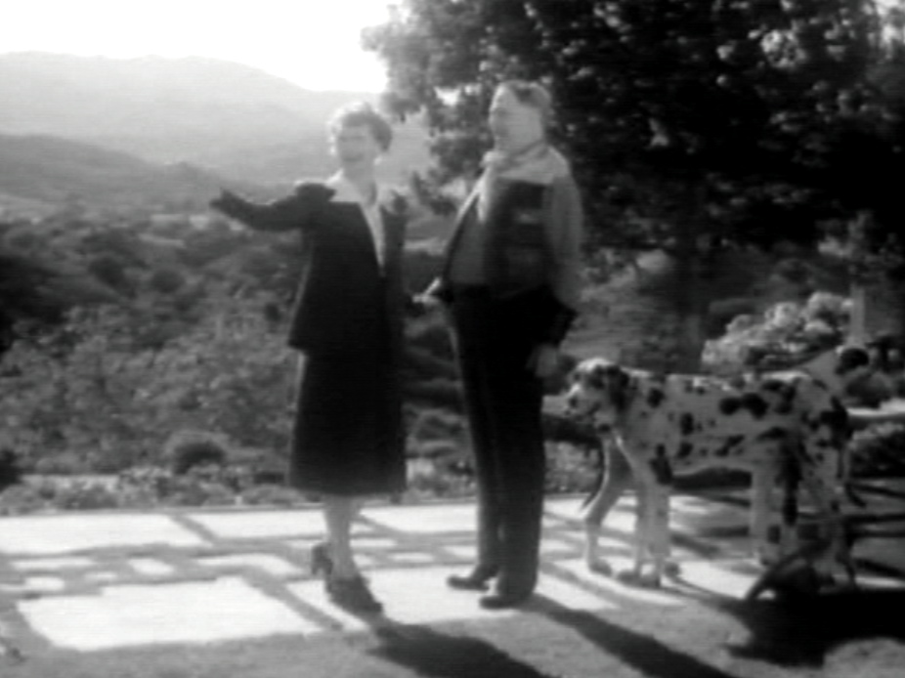
Hedda Hopper’s Hollywood
This features several visits with several Hollywood stars in ’42 & ’43, and the part with Bill Hart is only about a minute and a half long. Nonetheless, it is a real treat and was worth the price. During that minute and a half, you get to see Bill, 4 years before his death, in his backyard at his home here in Newhall with Prince and Gal, his beloved Great Danes. You also get to see him firing a pistol in the backyard! There’s a scene in the living room with a fire in the fireplace, and you get a glimpse at his wonderful pistol collection which was stolen some years back and never recovered. For those of us who visit the house frequently, it was so neat to see Bill walking the grounds of La Loma De Los Vientos!

The Ruse
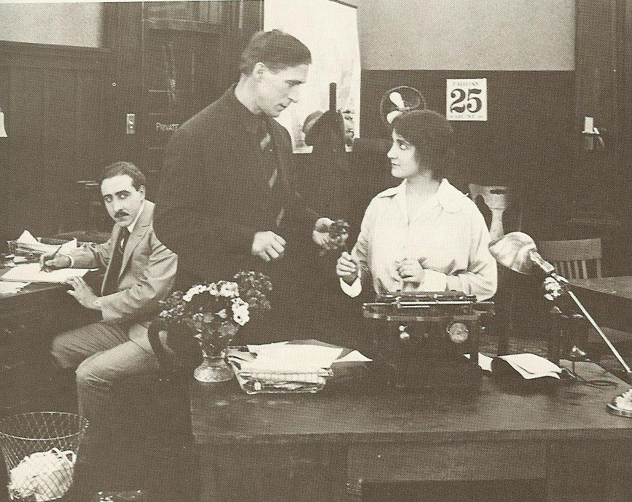
I really like this little melodrama. It starts out where most of Bill’s movies leave off: he’s a reformed gunfighter. But in this movie, he goes to the Chicago where he is out of his element, and ends up getting cheated by city-folk. One of the swindlers is a pretend-cowboy who looks an awful lot like Bill’s rival in the movies, Tom Mix! He’s even wearing the same kind of 20+ gallon hat that Mix used to!
Directed by Bill Hart, this was shot in the part of Los Angeles near where Dodger Stadium is today. Bill’s love interest in the movie is played again by Clara Williams, the same actress in The Bargain and Hell’s Hinges.

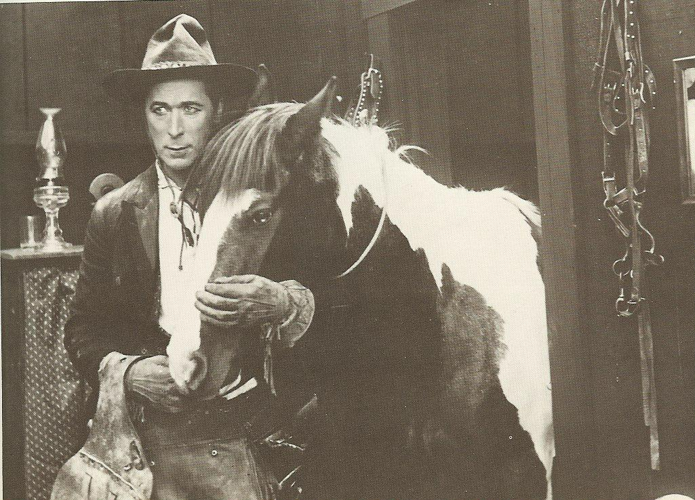
A Knight of the Trails
Unlike Bill’s usual plots in which he’s a bad man, turned good by the love of a woman, here he’s already got the girl, and is still bad! Lucky for our hero, she falls for someone worse.
This two-reeler, also directed by Bill, is very engaging. As always, Bill can act in such a way that you see his conversion from bad to good written all over his face.
The fellow that plays the bad guy… well, worse guy, is Frank Borzage, who later became a director, directing over 100 movies well into the 1950’s. He was awarded the first-ever Best Directing Oscar in 1929.

Keno Bates, Liar
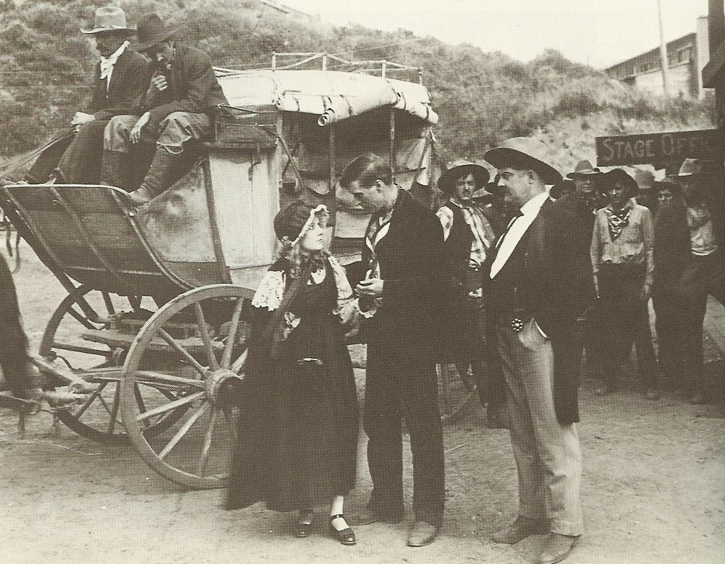
This one has an interesting plot involving Hart killing a fellow what needed killin’. Later, when the victim’s sister comes to town, Hart pretends that her brother was an honest man who died by accident, to save her feelings. It was written by J. G. Hawks, who 3 years later, reworked some of the same story elements into a better, full-length picture for Hart called Blue Blazes Rawden. Unlike Keno, Rawden has a much stronger, and darker ending.
All three of these shorts are two reelers, and if you’re new to silent films and don’t feel like you have the patience for a full-length silent, you might try one of these to get your feet wet. All three films feature Bill Hart as the director, and best of all, all three feature Bill’s Pinto Pony Fritz!

The Films of William S. Hart
Year | Starred | Directed | Produced | Wrote | Prints Exist? | DVD Availability | Format
1928 | Show People |  |  |  | Y
1925 | Tumbleweeds | ★ | ★ |  | Y | Amazon, elsewhere | DVD
1924 | Hello, 'Frisco
1924 | Singer Jim McKee |  |  | ★ | Y
1923 | Wild Bill Hickok |  | ★ | ★ | Y
 | Hollywood |  |  |  | N
1922 | Travelin' on |  |  | ★ | Y
1921 | White Oak |  | ★ | ★ | Y
1921 | Three Word Brand |  | ★ |  | Y
1921 | The Whistle |  |  |  | Y
1921 | O'Malley of the Mounted |  | ★ | ★ | Y
1920 | The Testing Block |  |  | ★ | Y
1920 | The Cradle of Courage | ★ | ★ |  | Y | GrapevineVideo.com | DVD-R
1920 | Sand! |  | ★ |  | Y
1920 | The Toll Gate |  | ★ | ★ | Y | Amazon, elsewhere | DVD
1919 | John Petticoats |  |  |  | Y
1919 | Wagon Tracks |  | ★ |  | Y | Amazon, elsewhere | DVD
1919 | Square Deal Sanderson | ★ |  |  | Y
1919 | The Money Corral | ★ | ★ | ★
1919 | The Poppy Girl's Husband | ★ | ★ |  | Y
1919 | Breed of Men |  | ★ |  | Y
1918 | Branding Broadway | ★ | ★ |  | Y
1918 | The Border Wireless | ★ | ★
1918 | Riddle Gawne | ★ | ★ |  | P | Amazon (partial) | DVD
1918 | Shark Monroe | ★ | ★ |  | Y
1918 | Selfish Yates | ★ |  |  | Y
1918 | The Tiger Man | ★ |  |  | Y
1918 | Blue Blazes Rawden | ★ |  |  | Y | SinisterCinema.com | DVD-R
1918 | United States Fourth Liberty Loan Drive
1918 | Canadian Victory War Drive
1918 | A Bullet for Berlin | ★
1918 | The Lion of the Hills
1918 | Staking His Life
1918 | Wolves of the Rail | ★ | ★ |  | Y
1917 | The Narrow Trail | ★ |  | ★ | Y | EncoreHomeVideo.com | DVD-R
1917 | The Silent Man | ★ | ★ |  | Y | ReelClassicDVD.com | DVD-R
1917 | The Cold Deck | ★
1917 | Wolf Lowry | ★ |  |  | Y
1917 | The Square Deal Man | ★ |  |  | Y | SinisterCinema.com | DVD-R
1917 | The Desert Man | ★ |  |  | P
1917 | The Gun Fighter | ★
1917 | All-Star Production of Patriotic Episodes for the Second Liberty Loan |  |  |  | P
1916 | Truthful Tulliver | ★ |  |  | Y
1916 | The Devil's Double | ★
1916 | The Return of Draw Egan | ★ |  |  | Y | GrapevineVideo.com | DVD-R
1916 | The Dawn Maker | ★
1916 | The Patriot | ★
1916 | The Captive God |  |  |  | Y
1916 | The Apostle of Vengeance | ★ |  |  | N
1916 | The Primal Lure | ★
1916 | The Aryan | ★ |  |  | Y
1916 | Hell's Hinges | ★ |  |  | Y
1915 | Between Men | ★ |  |  | Y
1915 | The Disciple | ★ |  |  | Y
1915 | Keno Bates, Liar | ★ |  |  | Y | GrapevineVideo.com | DVD-R
1915 | A Knight of the Trails | ★ |  |  | Y | GrapevineVideo.com | DVD-R
1915 | Cash Parrish's Pal | ★ |  |  | Y
1915 | The Ruse | ★ |  |  | Y | GrapevineVideo.com | DVD-R
1915 | Tools of Providence | ★ |  |  | Y
1915 | The Conversion of Frosty Blake | ★ |  |  | Y
1915 | The Darkening Trail | ★ |  |  | Y
1915 | Bad Buck of Santa Ynez | ★ | ★ |  | Y
1915 | The Taking of Luke McVane | ★ |  |  | Y
1915 | On the Night Stage |  |  |  | Y
1915 | The Roughneck | ★ |  |  | Y
1915 | The Sheriff's Streak of Yellow | ★
1915 | The Grudge | ★
1915 | The Scourge of the Desert | ★
1915 | Grit | ★
1915 | The Man from Nowhere | ★
1915 | Mr. 'Silent' Haskins | ★ |  |  | Y
1915 | Pinto Ben | ★ |  |  | Y
1914 | In the Sage Brush Country | ★ |  |  | Y
1914 | Two-Gun Hicks | ★
1914 | The Bargain |  |  | ★ | Y | SinisterCinema.com | DVD-R
1914 | Jim Cameron's Wife
1914 | His Hour of Manhood

